

MSc Data Science Project 7PAM2002
Department of Physics, Astronomy and Mathematics

Data Science FINAL PROJECT REPORT

Project Title:
PREDICTING MOVIE BOX OFFICE REVENUE USING MACHINE LEARNING

Student Name and SRN:
LOKESWARI YARATAPALLI
24061216

Supervisor: CAROLYN DEVEREUX
Date Submitted: 22/06/2026
Word Count: 4890
DECLARATION STATEMENT

This report is submitted in partial fulfilment of the requirement for the degree of Master of Science in Data Science at the University of Hertfordshire.
I have read the detailed guidance to students on academic integrity, misconduct and plagiarism information at Assessment Offences and Academic Misconduct and understand the University process of dealing with suspected cases of academic misconduct and the possible penalties, which could include failing the project or course.
I certify that the work submitted is my own and that any material derived or quoted from published or unpublished work of other people has been duly acknowledged. (Ref. UPR AS/C/6.1, section 7 and UPR AS/C/5, section 3.6)
I did not use human participants in my MSc Project.

I hereby give permission for the report to be made available on module websites provided the source is acknowledged.

Student Name printed: LOKESWARI YARATAPALLI

Student Name signature: Y. Lokeswari

Student SRN number:24061216

UNIVERSITY OF HERTFORDSHIRE
SCHOOL OF PHYSICS, ENGINEERING AND COMPUTER SCIENCE

PREDICTING MOVIE BOX OFFICE REVENUE USING MACHINE LEARNING

Git-hub link: https://github.com/sriloki4887/TMDB-Research-project-.git.

ACKNOWLDGEMENT

I would like to express my sincere gratitude to my project supervisor for their continuous guidance, valuable feedback, and support throughout this research. Their expertise and encouragement helped me successfully complete this project.

I would also like to thank the University of Hertfordshire for providing the academic resources and learning environment necessary for conducting this research. Special thanks to The Movie Database (TMDB) for making movie data publicly accessible, which formed the foundation of this study.

Finally, I would like to thank my family and friends for their constant encouragement, patience, and support during the completion of this project.

ABSTRACT

Movie box office revenue prediction is important for studios, investors, and distributors when making financial decisions. This project investigates whether movie features such as budget, runtime, genre, popularity, vote average, and vote count can predict revenue using machine learning.

A machine learning pipeline was developed using data from The Movie Database (TMDB). Data preprocessing, feature engineering, and model evaluation were performed before training four models: Linear Regression, Random Forest, Gradient Boosting, and MLP Regressor.

Results showed that ensemble learning methods outperformed traditional linear models. Gradient Boosting achieved the best overall performance, demonstrating its ability to capture complex relationships between movie characteristics and revenue. The analysis identified budget, popularity, and vote count as the strongest predictors of box office success.

The findings suggest that machine learning can support data-driven decision-making in the film industry and provide a foundation for future revenue forecasting systems.

Table of Contents

Chapter 1: Introduction 13
  - Overview 13
  - Purpose of the Project 13
  - Relevance to Industry............................................................................................13
  - Research Aim and Objectives 14
  - Research Questions 14
  - Scope of the Project 14
  - Summary 15
Chapter 2: Background 16
  - Introduction 16
  - Movie Revenue Prediction: An Overview 16
  - Machine Learning in Revenue Forecasting 16
  - Factors Influencing Movie Success 16
  - Summary 16
Chapter 3: Dataset and Exploratory Data Analysis 17

3.1 Dataset Source………………………………………………………………………........17

3.2 Dataset Specifications…………………………………………………………………….17

3.3 Exploratory Data Analysis………………………………………………………………...18

Chapter 4: Ethical Considerations ..................................................................................22

4.1 Personal and Sensitive Data .............................................................................22

4.2 GDPR Compliance ............................................................................................22

4.3 Institutional Ethical Approval Requirements ....................................................22

4.4 Permissions and Licensing ..............................................................................22

4.5 Responsible Use of Machine Learning ............................................................22

4.6 Summary of Ethical Compliance ......................................................................23

Chapter 5: Methodology .........................................................................................24

5.1 Overview of the Approach ..............................................................................24

5.2 Dataset Collection ..........................................................................................25

5.3 Data Cleaning ................................................................................................25

5.4 Feature Selection ...........................................................................................25

5.5 Feature Engineering ......................................................................................25

5.6 Data Preprocessing .......................................................................................26

5.7 Train-Test Split ..............................................................................................26

5.8 Model Development ......................................................................................26

5.8.1 Linear Regression ......................................................................................26

5.8.2 Random Forest Regressor .........................................................................26

5.8.3 Gradient Boosting Regressor .....................................................................26

5.8.4 MLP Regressor ..........................................................................................26

5.9 Hyperparameter Tuning ................................................................................27

5.10 Model Evaluation .........................................................................................27

5.11 Best Model Selection ..................................................................................27

5.12 Summary ....................................................................................................27

Chapter 6: Analysis and Discussion ............................................................................28

6.1 Interpretation of EDA Results .........................................................................28

6.2 Genre and Outlier Analysis .............................................................................30

6.3 Model Performance Analysis ...........................................................................31

6.4 Hyperparameter Tuning Analysis ....................................................................32

6.5 Cross-Validation Discussion ............................................................................33

6.6 Feature Importance Analysis ...........................................................................34

6.7 Best Model Discussion ....................................................................................35

6.8 MLP Learning Analysis ....................................................................................36

6.9 Practical Implications .......................................................................................37

6.10 Limitations .....................................................................................................38

6.11 Summary .......................................................................................................39

Chapter 7: Conclusion ...........................................................................................39

7.1 Summary of Key Findings ...............................................................................39

7.2 Research Question Achievement ....................................................................39

7.3 Practical Implications .......................................................................................39

7.4 Limitations of the Study ...................................................................................40

7.5 Directions for Future Work ..............................................................................40

7.6 Final Conclusion .............................................................................................40

References ...................................................................................................................41

LIST OF FIGURES

Figure 3.1 Distribution of Log-Transformed Movie Revenue.............................18

Figure 3.2 Relationship Between Budget and Revenue....................................19

Figure 3.3Correlation Heatmap of Numerical Features………………………….19

Figure 3.4 Top 10 Genres by Average Revenue ..............................................19

Figure 3.5 Movie Features Influencing Revenue...............................................20

Figure 5.1 Machine Learning Workflow for Movie Revenue Prediction.............25

Figure 6.1 Distribution of Log-Transformed Movie Revenue.............................29

Figure 6.2 Relationship Between Budget and Revenue....................................29

Figure 6.3 Correlation Heatmap of Numerical Features ...................................30

Figure 6.4 Top Genres by Average Revenue ...................................................30

Figure 6.5 Outlier Analysis of Movie Features ..................................................31

Figure 6.6 Performance Comparison of Machine Learning Models ..................31

Figure 6.7 Random Forest Hyperparameter Tuning Results ............................32

Figure 6.8 Gradient Boosting Hyperparameter Tuning Results ........................33

Figure 6.9 MLP Hyperparameter Tuning Results ..............................................33

Figure 6.10 Cross Validation R² Comparison Across Models.............................34

Figure 6.11 Feature Importance Analysis...........................................................35

Figure 6.12 Actual vs Predicted Revenue Using Gradient Boosting...................36

Figure 6.13 Residual Distribution of the Best Model...........................................36

Figure 6.14 MLP Performance vs Epochs...........................................................37

Figure 6.14 MLP Loss vs Epochs........................................................................37

LIST OF TABLES

Table 3.1 Selected Features for Revenue Prediction ........................................17

Table 3.2 Dataset Summary Statistics ...............................................................21

Table 6.1 Model Performance Results ...............................................................31

Table 6.2 Hyperparameter Tuning Results ........................................................32

Table 6.3 Feature Importance Ranking for Revenue Prediction ........................34

Table 6.4 Final Tuned Model Comparison .........................................................35

Table 6.5 MLP Training Configuration ................................................................37

Chapter 1: Introduction

Overview

Every year, the film industry spends billions of dollars on marketing, distribution, and production. Due to the numerous variables affecting audience behaviour and market performance, forecasting a film's financial success before to its debut is still quite difficult.
Conventional forecasting methods frequently depend on professional judgments and past patterns, which might not adequately represent intricate connections between movie attributes. The ability to evaluate massive amounts of movie-related data and produce more precise income forecasts is made possible by recent developments in machine-learning.
Using TMDB database, this study investigates the application of machine learning techniques to forecast movie box office income. The study assesses several machine learning algorithms and looks at which aspects of movies make the most contributions.

Purpose of the Project

The goal of this project is to use publicly accessible movie data to create and assess machine learning models that can forecast box office receipts.

The purpose of the study is to ascertain whether movie attributes such budget, runtime, genre, popularity, vote average, and vote count may reliably predict future earnings. Additionally, the research aims to determine the best prediction model and the most significant factors influencing film performance.

Relevance to Industry

In the entertainment sector, revenue forecasting is crucial. For directing production budgets, marketing plans, and release schedules, film studios, financiers, distributors, and marketing teams depend on precise estimates.

By lowering financial risks and enhancing resource allocation, machine learning-based prediction systems can aid in strategic decision-making. Before making large investments, businesses may be able to identify high-potential initiatives with the aid of accurate Projections.

Predictive analytics provides significant value for enhancing business outcomes as data-driven decision-making becomes more crucial in the entertainment industry.

Research Aim and Objectives

Aim:

To create and assess machine learning models that use movie metadata from The Movie Database (TMDB) to forecast box office receipts.

Objectives:

1.4.1 To gather and prepare TMDB movie data.
1.4.2 To analyze data exploratorily in order to comprehend feature relationships.
1.4.3 To create features that are appropriate for modeling machine learning.
1.4.4 To create several machine learning models to forecast income.
1.4.5 To use regression assessment measures to compare model performance.
    - To determine which factors, have the biggest impact on film income.
1.4.7 To offer suggestions for upcoming enhancements to the revenue forecasting system.

1.5 Research Questions

- Can box office revenue be predicted by movie attributes such budget, runtime, genre, popularity, vote average, and vote count?
- Which machine learning model forecasts revenue the most accurately?
- What aspects of a film have the biggest impact on its box office performance?
- Can financial decision-making in the film industry be aided by predictive analytics?

Scope of the Project

Movie metadata gathered from TMDB is the study's main emphasis. Movie budgets, popularity ratings, audience ratings, runtime, genres, and income are all included in the dataset.

Regression analysis is done using supervised machine learning techniques in this project. Four algorithms for machine learning are assessed:

- Linear Regression
- Random Forest Regressor
- Gradient Boosting Regressor
- MLP Regressor

The study is restricted to the features found in the TMDB dataset and excludes outside factors like marketing spending, social media interaction, actor popularity, or the state of the economy.

This chapter presented the rationale behind movie revenue forecasting and emphasized its significance in the entertainment sector. The project's scope, questions, objectives, and research goals were determined. The literature on machine learning applications and movie revenue prediction is reviewed in the next chapter.

Summary

This chapter presented the theory behind movie revenue forecasting and emphasized its significance in the entertainment sector. The project's scope, questions, objectives, and research goals were determined. The literature on machine learning applications and movie revenue prediction is reviewed in the next chapter.

Chapter 2: Background

Introduction

Because of its financial importance and the intricacy of elements impacting audience behaviour, movie revenue prediction has garnered a lot of attention from scholars.
Because machine learning approaches can simulate nonlinear correlations and interactions between several factors, they are being used more in revenue forecasting.

Movie Revenue Prediction: An Overview

Movie revenue prediction estimates a film’s financial performance before or shortly after release. Previous studies have shown that factors such as budget, popularity, genre, audience ratings, and release strategy influence box office outcomes. Predicting revenue accurately remains challenging because these factors interact in complex ways.

Machine Learning in Revenue Forecasting

Machine learning has become widely used for predictive analytics because it can identify complex patterns within large datasets. Linear Regression provides a baseline approach, while Random Forest, Gradient Boosting, and MLP models can capture nonlinear relationships and improve prediction accuracy.

Factors Influencing Movie Success

Budget, popularity, audience engagement, genre, and ratings are commonly recognized as important predictors of movie success. These variables were therefore selected for this study.

Summary

According to the literature, machine learning models offer useful tools for predicting movie income. Prior research emphasizes the significance of funding, popularity, audience engagement, and genre as significant factors. These results serve as the basis for the stages of dataset analysis and modeling that are discussed in the following chapter.

Chapter 3: Dataset and Exploratory Data Analysis
  - Data set link: https://www.themoviedb.org/

The Movie Database (TMDB), a publicly accessible movie information portal with a wealth of film metadata, provided the dataset used in this project. Thousands of films as well as financial, popularity, rating, and genre-related data are included in the dataset.

Dataset specifications:
The dataset had more than 10,000 movie recordings after preprocessing and cleaning. The variables listed below were chosen for modeling:
Feature | Description
Budget | The film's production budget
Revenue | (Target Variable) Box office revenue
Runtime | The length of the film in minutes
Main Genre | The main genre of a film
Popularity | TMDB popularity rating
Vote Average | Average rating from the audience
Vote Count | Total votes cast by the audience
To enhance the performance of the model:
- Values that were missing were eliminated.
- Films having no budget and no revenue were not included.
- The primary genre was taken out of the genre classifications.
- To lessen skewness, revenue and budget were log-transformed.
- The numerical characteristics were standardized.
- One-hot encoding was used for genre features.
- Genre features were one-hot encoded.

EXPLORATORY DATA ANALYSIS (EDA):

Before developing a model, exploratory data analysis was used to comprehend feature distributions, spot trends, and look at correlations between variables.

Revenue Distribution

A few hit films generated exceptionally large revenues, and revenue data showed a considerable positive skewness.

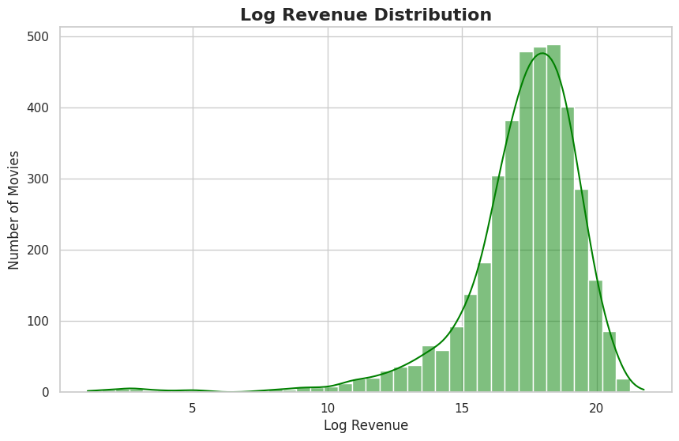

Figure 3.1: Distribution of Log-Transformed Movie Revenue

A logarithmic adjustment was used to normalize the distribution and enhance modelling performance to solve this problem.

Budget vs Revenue

Scatter plot analysis revealed a positive relationship between production budget and revenue.
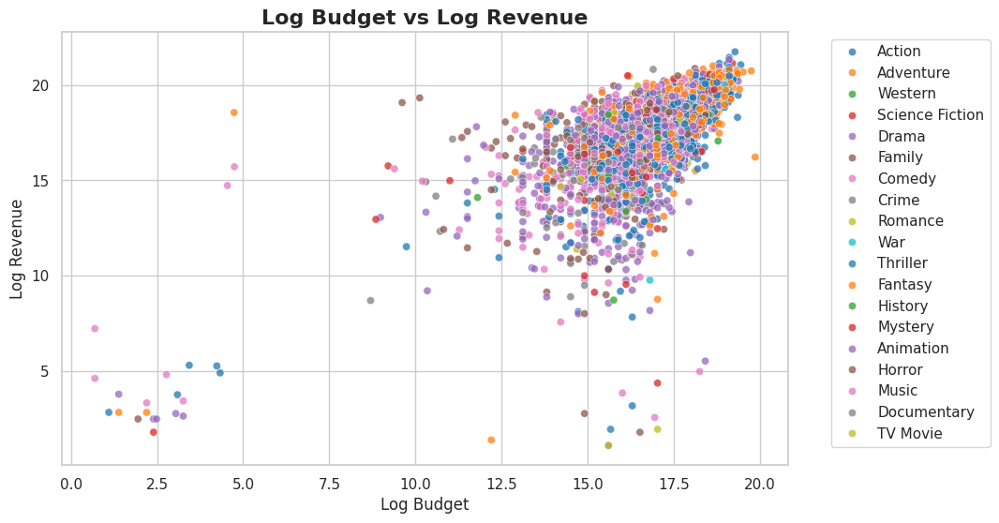

Figure 3.2: Relationship Between Budget and Revenue

Though there were some notable exceptions, films with bigger budgets often made more money at the box office.

Correlation Heatmap

Budget and popularity had the biggest positive correlations with revenue, according to the correlation matrix. Additionally, there was a moderately favourable association with vote count.

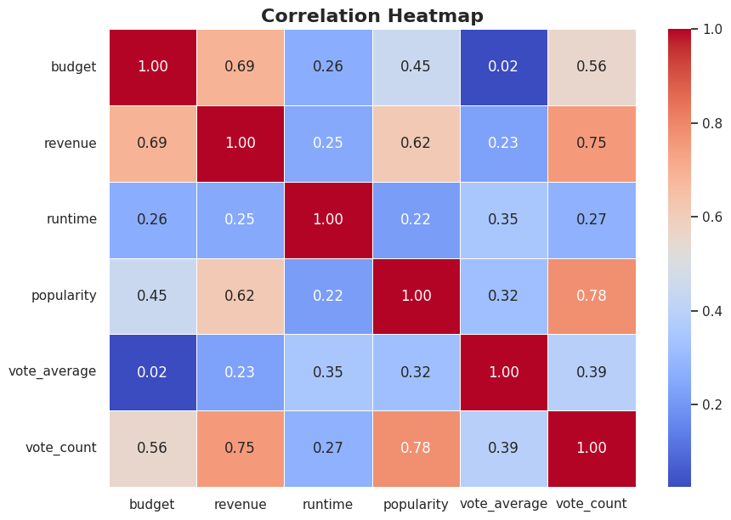

Figure 3.3: Correlation Heatmap of Numerical Features

The vote average showed a negative correlation with revenue, indicating that audience ratings might not be the only factor in determining financial success.

Genre Analysis

Movie categories differed substantially, according to genre-based revenue research.
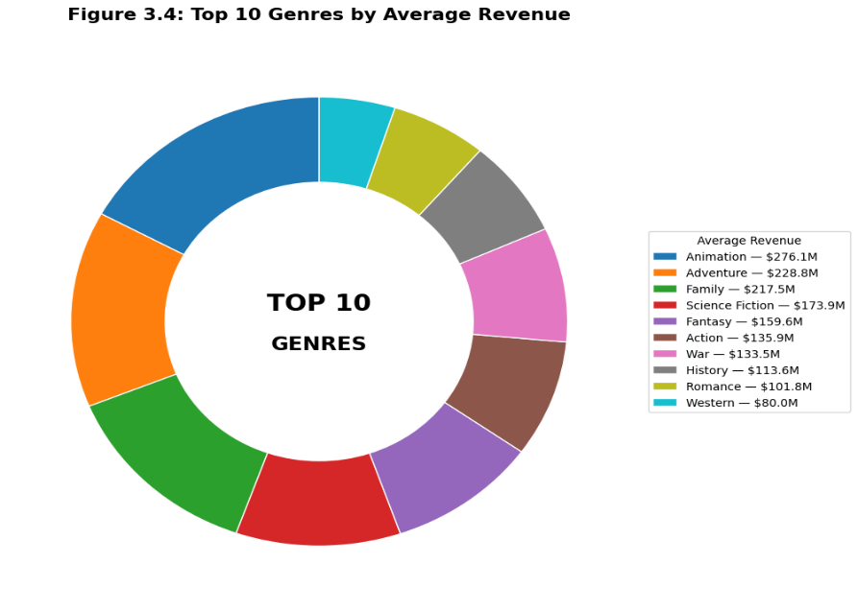
Figure 3.4: Top 10 Genres by Average Revenue

The average revenue of action, adventure, and animation films was often higher than that of drama and documentary films.

Outlier Analysis

Boxplots revealed several extreme values in the revenue and budget variables.

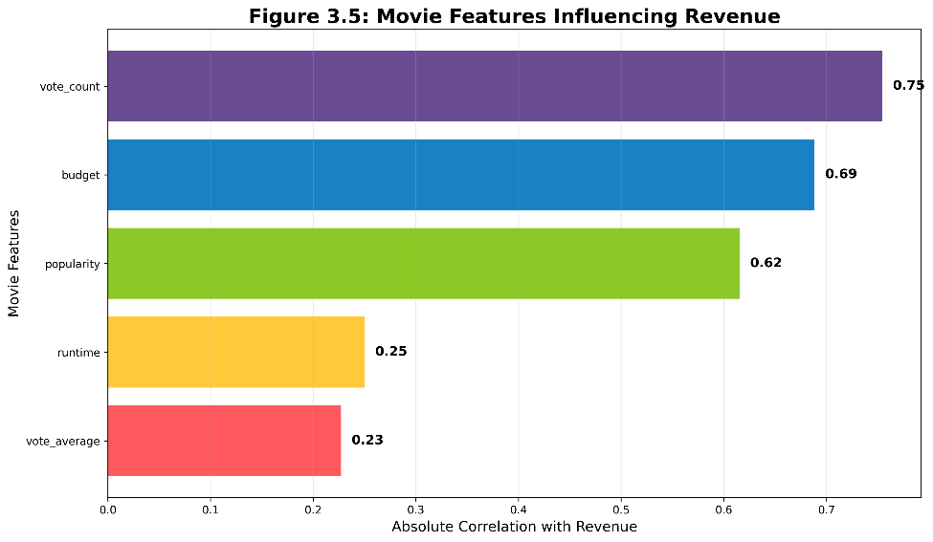

Figure 3.5: Movie Features Influencing Revenue

These findings were protected because they reflect real market behaviour rather than data errors, and they correlated with significant blockbuster productions.

Key Findings from EDA

• The budget and revenue are closely related.

• Financial success is greatly influenced by popularity.

• The number of votes cast indicates audience involvement, which helps forecast income.

• Commercial performance is impacted by genre.

• To handle skewed financial data, log transformation is required.

The application of machine learning methods that can represent nonlinear interactions between video characteristics is supported by these findings.

Chapter 4: Ethical Considerations

4.1 Personal and Sensitive Data

The TMDB dataset contains publicly available movie metadata and does not include personal or sensitive information. Therefore, privacy risks are minimal, and the data was used solely for academic research purposes.

4.2 GDPR Compliance

Since the dataset contains no personal identifiable information, GDPR requirements are not directly applicable. However, responsible data management practices were followed throughout the project.

4.3 Institutional Ethical Approval Requirements

No human participants, surveys, interviews, or personal data were involved. Consequently, formal ethical approval was not required.

4.4 Permissions and Licensing

The movie data used in this project were obtained from The Movie Database (TMDB), a widely recognized online movie information platform. TMDB provides publicly accessible movie metadata that can be used for educational, research, and non-commercial purposes subject to its terms of use.

The dataset was accessed and used solely for academic research purposes. Proper acknowledgement of TMDB as the original data source has been provided throughout the report. No copyrighted media content, proprietary information, or restricted data were used in this research.

4.5 Responsible Use of Machine Learning

Machine learning models can influence decision-making processes in many industries. In this project, the predictive models were developed solely for educational and research purposes to investigate the feasibility of forecasting movie box office revenue.

The models were evaluated using transparent performance metrics including Mean Absolute Error (MAE), Root Mean Squared Error (RMSE), R² Score, and Cross-Validation Scores. The study recognizes that prediction models may contain limitations and should not be considered as definitive indicators of movie success. Factors such as marketing expenditure, actor popularity, release timing, and audience sentiment were not included in the dataset and may influence prediction outcomes.

4.6 Summary of Ethical Compliance

Ethical considerations were carefully addressed throughout this research. The dataset contained no personal or sensitive information, ensuring compliance with privacy and data protection principles. The project relied exclusively on publicly available movie metadata, eliminating the need for ethical approval involving human participants.

The study complied with responsible research practices, respected data usage permissions, and maintained transparency throughout the machine learning development process. Consequently, the project was conducted in an ethical, lawful, and academically responsible manner.

Chapter 5: Methodology

5.1 Overview of the Approach

This chapter explains the step-by-step methodology used to predict movie box office revenue using machine learning. The process included dataset collection, data cleaning, exploratory analysis, feature engineering, preprocessing, model development, hyperparameter tuning, and model evaluation.

The dataset was obtained from The Movie Database (TMDB). The selected features included budget, runtime, genre, popularity, vote average, and vote count. The target variable was movie revenue. Since revenue is a continuous numerical value, this project was treated as a regression problem.

🔵 TMDB DATASET
│
▼
🟢 DATA CLEANING
│
▼
🟣 FEATURE ENGINEERING
│
▼
🟠 DATA PREPROCESSING
│
▼
🔷 TRAIN / TEST SPLIT
│
────────┬─────
▼ ▼ ▼ ▼
🔵LR 🟢RF 🟠GBR 🟣MLP
────────┴─────
│
▼
🔴 HYPERPARAMETER
TUNING
│
▼
🟡 EVALUATION
(MAE, RMSE, R²)
│
▼
⭐ BEST MODEL SELECTED
(Gradient Boosting)

Figure 5.1: Machine Learning Workflow for Movie Revenue Prediction

5.2 Dataset Collection

The first step was to collect movie data from TMDB. The dataset contained movie-related information such as budget, revenue, runtime, genre, popularity score, vote average, and vote count. These variables were selected because they are relevant to movie performance and can influence box office revenue.

5.3 Data Cleaning

Missing and invalid records were removed. Movies with zero budget, revenue, or runtime were excluded to improve data quality and model reliability.

5.4 Feature Selection

The selected input features for model training were:

* Budget
* Runtime
* Popularity
* Vote Average
* Vote Count
* Main Genre

The target variable was:

* Revenue

These features were chosen because they represent financial investment, audience interest, movie duration, audience rating, engagement level, and movie category.

5.5 Feature Engineering

Feature engineering was carried out to improve model performance. The original genre column contained multiple genres for some movies. Therefore, the first genre was extracted and used as the main genre.

Budget and revenue values were highly skewed because some blockbuster movies earned extremely high revenue. To reduce this skewness, log transformation was applied using the `log1p () ` function. This helped make data distribution more balanced and suitable for machine learning models.

5.6 Data Preprocessing

Numerical features were scaled, and missing values were imputed. Categorical features were encoded using One-Hot Encoding. A Column Transformer combined all preprocessing steps into a single pipeline.

5.7 Train-Test Split

The dataset was divided into training and testing sets. Eighty percent of the data was used for training the models, and twenty percent was used for testing.

A random state value of 42 was used to make the results reproducible. This means that the same train-test split can be generated every time the code is run.

5.8 Model Development

Four regression models were developed and compared:

5.8.1 Linear Regression

Linear Regression was used as the baseline model. It assumes a linear relationship between movie features and revenue. This model helped provide a simple comparison point for more advanced models.

5.8.2 Random Forest Regressor

Random Forest Regressor is an ensemble learning model that combines many decision trees. It improves prediction performance by reducing overfitting and capturing nonlinear relationships in the dataset.

5.8.3 Gradient Boosting Regressor

Gradient Boosting Regressor builds decision trees sequentially. Each new tree corrects the errors made by the previous trees. This model is effective for learning complex nonlinear patterns and improving prediction accuracy.

5.8 MLP Regressor
MLP Regressor is a neural network model. It uses hidden layers and activation functions to learn complex relationships between input features and revenue. Early stopping was used to prevent overfitting during training.

5.9 Hyperparameter Tuning

Hyperparameter tuning was conducted using Randomized-Search-CV to identify the most effective model settings. Different parameter combinations were tested for Random Forest, Gradient Boosting, and MLP models to improve prediction performance. Cross-validation was applied during the tuning process to ensure that the models remained reliable and performed consistently across different subsets of the data.

5.10 Model Evaluation

The models were evaluated using regression performance metrics:

Mean Absolute Error (MAE)

MAE measures the average prediction error. A lower MAE means the model predictions are closer to the actual revenue values.

Root Mean Squared Error (RMSE)

RMSE gives more weight to large errors. A lower RMSE indicates better prediction performance.

R² Score

R² measures how much variation in revenue is explained by the model. A higher R² score means better model performance.

Cross-Validation R²

Cross-validation R² was used to check whether the model performed consistently across different training and validation splits.

5.11 Best Model Selection

The best model was selected based on its ability to produce accurate and consistent predictions. Among the models tested, Gradient Boosting Regressor achieved the strongest overall performance, with the highest R² score and the lowest prediction errors. This indicated that it was the most suitable model for predicting movie box office revenue.

5.12 Summary

This chapter outlined the methodology used throughout the project, including data preparation, preprocessing, feature engineering, model development, hyperparameter tuning, and evaluation. These steps provided a structured framework for comparing the models and identifying the most effective approach for revenue prediction.

Chapter 6: Analysis and Discussion

6.1 Interpretation of EDA Results

The exploratory data analysis provided valuable insights into the TMDB dataset. Revenue was highly skewed because a small number of blockbuster films generated exceptionally high earnings. To address this issue, log transformation was applied to both revenue and budget.



Figure 6.1: Distribution of Log-Transformed Movie Revenue

The relationship between budget and revenue showed a clear positive trend, indicating that higher-budget films generally achieve greater box office success. However, several exceptions suggest that other factors also influence revenue.



Figure 6.2: Relationship Between Budget and Revenue


Figure 6.3: Correlation Heatmap of Numerical Features

The correlation analysis revealed that budget, popularity, and vote count had the strongest associations with revenue. These findings suggest that financial investment and audience engagement play important roles in determining movie success.

6.2 Genre and Outlier Analysis

Genre analysis showed noticeable differences in average revenue across movie categories. Action, Adventure, Animation, and Science Fiction films generally generated higher revenues than Drama and Documentary films.


Figure 6.4: Top 10 Genres by Average Revenue

Several outliers were identified in the budget and revenue variables. These records were retained because they represent real blockbuster movies and provide useful information about industry trends.



Figure 6.5: Outlier Analysis of Movie Features.

6.3 Model Performance Analysis

Four regression models were trained and compared:

Model | MAE | RMSE | R²
Gradient Boosting | 0.963 | 1.488 | 0.584
Random Forest | 0.987 | 1.543 | 0.553
MLP | 1.146 | 1.737 | 0.434
Linear Regression | 1.246 | 1.917 | 0.310
Table 6.1: Model Performance Results of Machine Learning Models

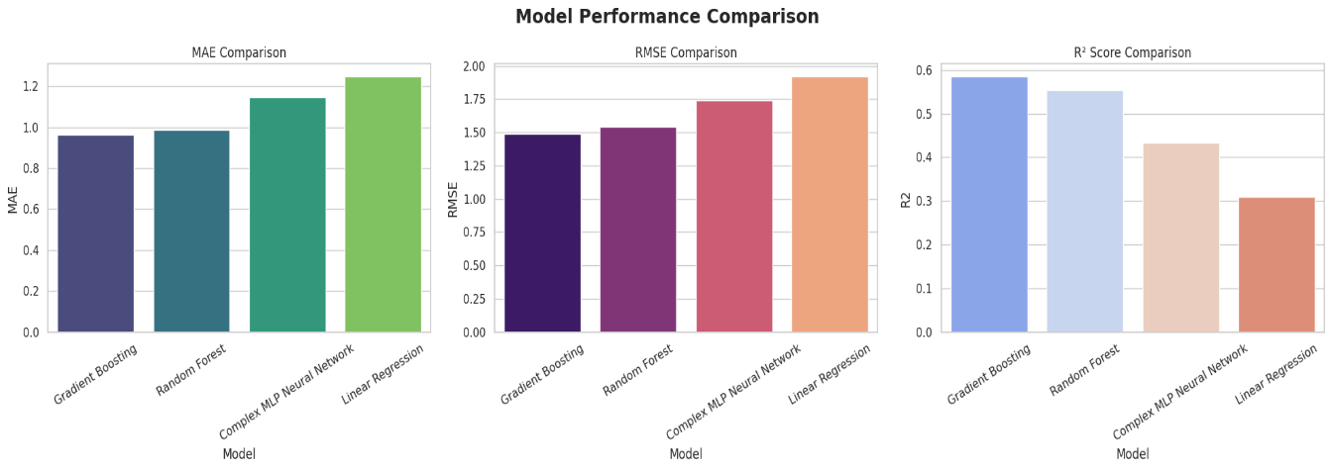

Figure 6.6: Performance Comparison of Machine Learning Models.

The performance of four machine learning models was compared using MAE, RMSE, and R² metrics. Gradient Boosting achieved the highest R² score and the lowest prediction errors, making it the strongest model overall. Random Forest produced similar results but with slightly lower performance.

MLP demonstrated moderate predictive capability and successfully captured nonlinear relationships within the data. Linear Regression produced the weakest results, suggesting that movie revenue is influenced by complex interactions that cannot be fully explained using a simple linear model.

6.4 Hyperparameter Tuning Analysis

Hyperparameter tuning was carried out using Randomized-Search-CV. The purpose of tuning was to test different parameter combinations and select the best model settings.

Model | Best Parameters
Linear Regression | Fit _intercept=True
Random Forest | n_ estimators=200, max _depth=10, min _samples _split=5, min _samples _leaf=4
Gradient Boosting | n_ estimators=100, learning _rate=0.05, max _depth=2, subsample=1.0
MLP | Hidden _layer _sizes= (128,64), activation=tanh, alpha=0.001

Table 6.2 – Hyperparameter Tuning Results

For Random Forest, parameters such as number of trees, maximum depth, minimum samples split, and minimum samples leaf were tested.

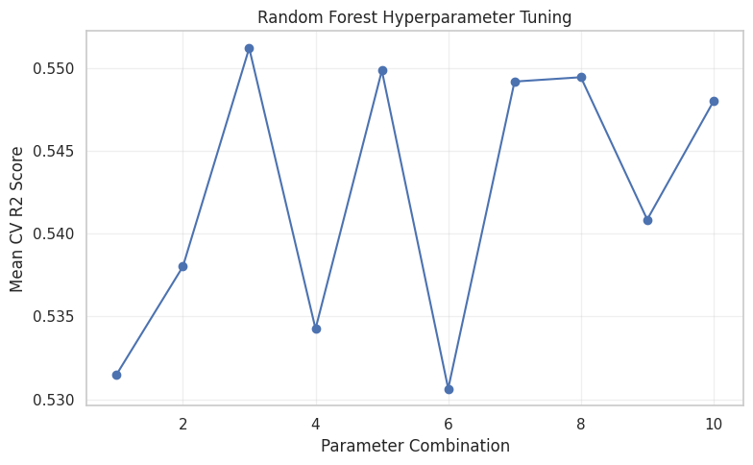

Figure 6.7: Random Forest Hyperparameter Tuning Results

For Gradient Boosting, parameters such as learning rate, number of estimators, and maximum depth were tested.

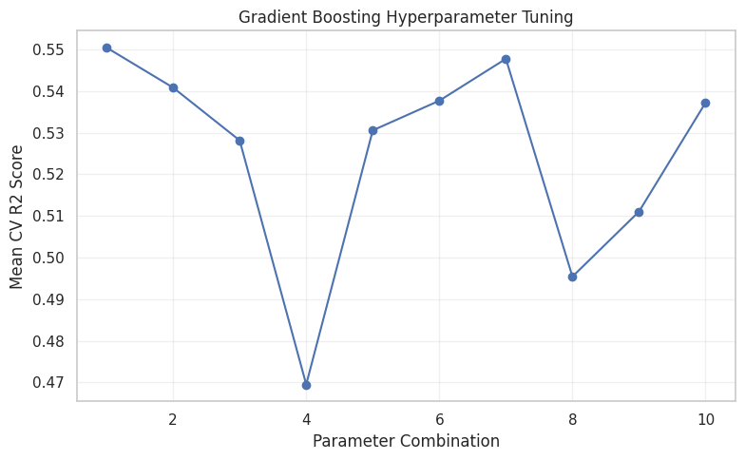

Figure 6.8: Gradient Boosting Hyperparameter Tuning Results

For MLP, hidden layer sizes, activation function, alpha value, and learning rate were tuned.

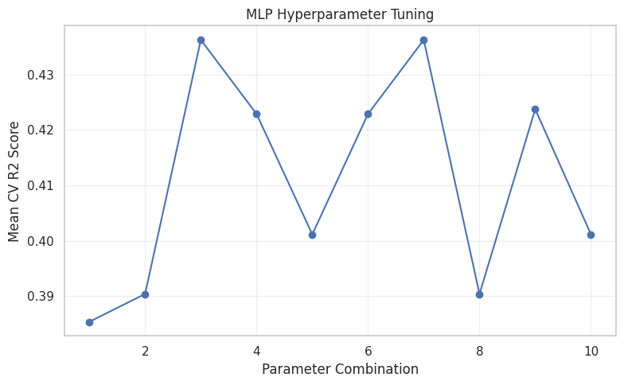

Figure 6.9: MLP Hyperparameter Tuning Results

The tuning results showed that model performance improved after selecting better parameter values. Gradient Boosting achieved the strongest tuning result and produced the best final model.

6.5 Cross-Validation Discussion

Cross-validation was used to evaluate model stability and generalisation. The results showed that Gradient Boosting and Random Forest maintained strong performance across different data splits.

Gradient Boosting achieved the highest average cross-validation score, indicating that it generalised effectively to unseen data and was less sensitive to variations in the training data.

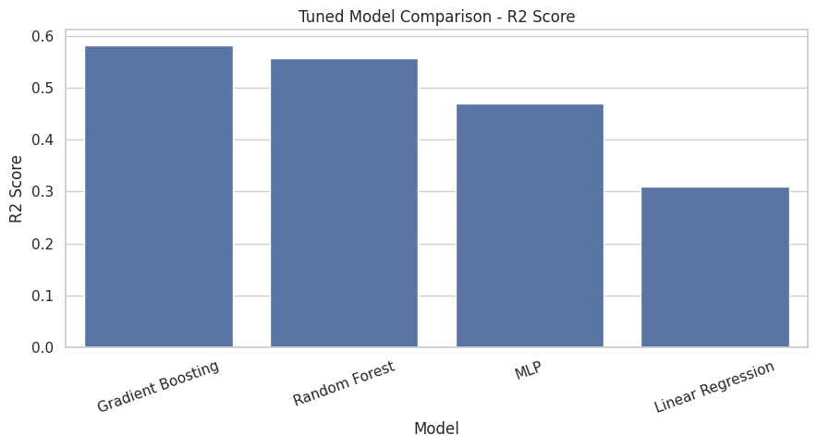

Figure 6.10: Cross Validation R² Comparison Across Models

6.6 Feature Importance Analysis

Feature importance analysis identified vote count, budget, and popularity as the most influential predictors of revenue. These variables reflect audience engagement, financial investment, and public interest.

Feature | Importance
Vote _count | 0.417
budget | 0.346
popularity | 0.071
runtime | 0.062
Vote _average | 0.054
Table 6.3: Feature Importance Ranking for Revenue Prediction

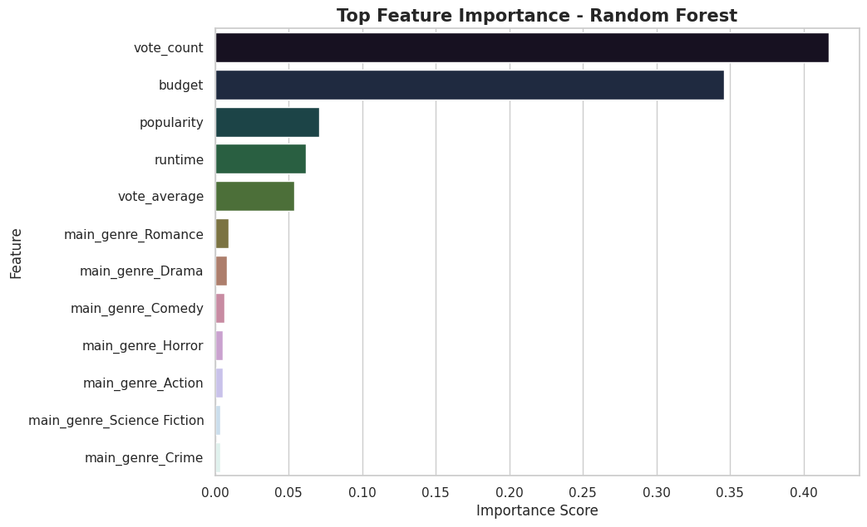

Figure 6.11: Feature Importance Analysis

In contrast, runtime and vote average contributed less to prediction performance, suggesting that strong audience ratings alone do not guarantee commercial success.

6.7 Best Model Discussion

Gradient Boosting Regressor was selected as the best-performing model because it achieved the highest R² score and the lowest prediction errors. Its sequential learning approach allows each new tree to correct the errors of previous trees, enabling the model to capture complex nonlinear relationships within the dataset.

Model | MAE | RMSE | R² Score
Gradient Boosting | 0.957 | 1.491 | 0.583
Random Forest | 0.979 | 1.537 | 0.556
MLP | 1.049 | 1.681 | 0.470
Linear Regression | 1.246 | 1.917 | 0.310

Table 6.4 – Final Tuned Model Comparison

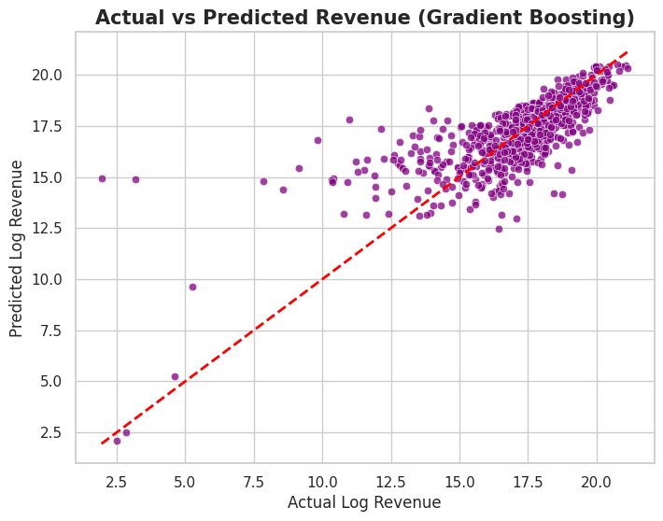

Figure 6.12: Actual vs Predicted Revenue Using Gradient Boosting

The actual-versus-predicted and residual plots further confirmed the model's ability to generate accurate and reliable predictions.

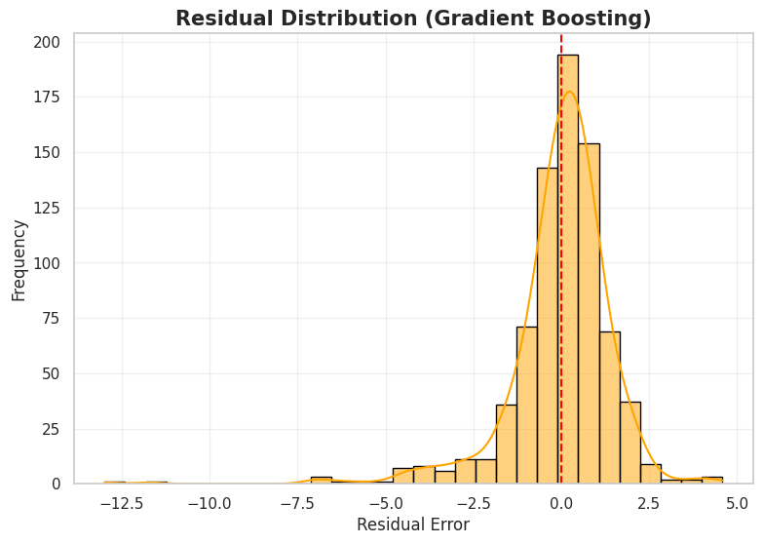

Figure 6.13: Residual Distribution of the Best Model

This allows the model to capture complex nonlinear relationships between budget, genre, popularity, vote count, and revenue.

6.8 MLP Learning Analysis

Although Gradient Boosting delivered the best overall performance, the MLP model also demonstrated effective learning behavior. The training and validation curves improved rapidly during the early epoch before stabilizing, indicating successful convergence.

Parameter Value
Hidden Layer Sizes (128,64)
Activation Function tanh
Learning Rate constantly
Alpha 0.001
Early Stopping Enabled

Table 6.5: MLP Training Configuration

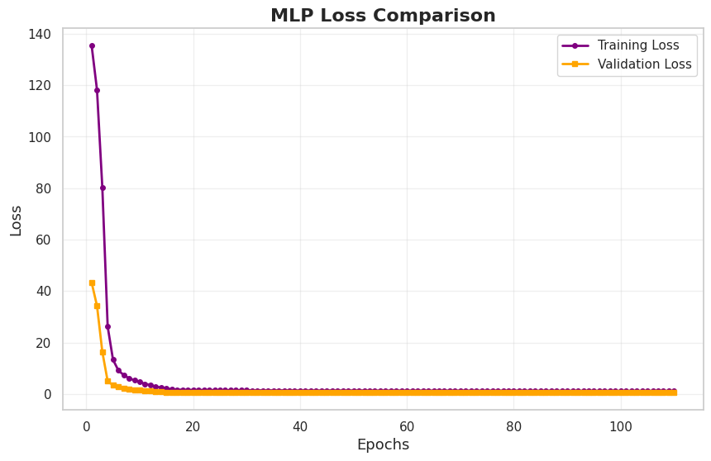

Figure 6.14 MLP Performance vs Epochs

The similarity between the curves suggests that the model generalized reasonably well and avoided significant overfitting. While its performance was lower than the ensemble models, it successfully learned nonlinear relationships within the data.

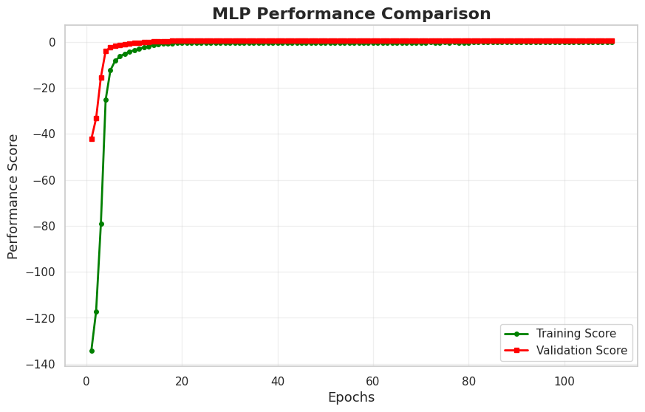

Figure 6.15 MLP Loss vs Epochs

6.8 Practical Implications

The findings demonstrate that machine learning can support revenue forecasting in the film industry. Studios and investors may use predictive models to evaluate potential projects and make more informed financial decisions before release.

6.9 Limitations

This study relied on features available within the TMDB dataset. Important factors such as marketing expenditure, actor popularity, release timing, critic reviews, and social media sentiment were not included. Incorporating these variables may improve future prediction accuracy.

6.10 Summary

This chapter discussed the analysis and results of the project step by step. The EDA showed important patterns in the dataset. Model comparison showed that ensemble models performed better than Linear Regression and MLP. Hyperparameter tuning improved performance, and Gradient Boosting was selected as the best model for predicting movie box office revenue.

Chapter 7: Conclusion

7.1 Summary of Key Findings

Using TMDB movie metadata, this study created machine learning models to estimate gross at the box office.

Budget, popularity, voting count, and genre were all strongly linked with revenue, according to exploration data analysis. The imbalance in revenue and budget figures was lessened with the use of log transformation.

The following four models were assessed: MLP Regressor, Random Forest Regressor, Gradient Boosting Regressor, and Linear Regression. Gradient Boosting performed the best overall among these models.

7.2 Practical Implications

The results indicate that predicting movie revenue can benefit from machine learning. Predictive models can be used by investors and film studios to assist with budgeting, marketing, and production planning.

Additionally, the initiative demonstrates that popularity and audience involvement are essential economic measures in the entertainment sector.

7.3 Directions for Future Work

By introducing additional factors like actor popularity, director repute, marketing budget, release date, reviewer ratings, and social media perspective, future research can increase accuracy of predictions.

Larger datasets and more effective deep learning models could possibly be evaluated. To enhance real-world performance, the model might also be updated frequently with fresh movie data.

References

Han, J., Kamber, M. and Pei, J. (2022) Data Mining: Concepts and Techniques. 4th ed. Morgan Kaufmann.

Géron, A. (2022) Hands-On Machine Learning with Scikit-Learn, Keras and TensorFlow. 3rd ed. O'Reilly Media.

James, G., Witten, D., Hastie, T. and Tibshirani, R. (2021) An Introduction to Statistical Learning. 2nd ed. Springer.

The Movie Database (TMDB) (2026) The Movie Database. Available at: https://www.themoviedb.org/ (Accessed: 30 May 2026).

Scikit-Learn Developers (2026) Scikit-Learn Documentation. Available at: https://scikit-learn.org/ (Accessed: 30 May 2026).

Bishop, C.M. (2006) Pattern Recognition and Machine Learning. New York: Springer.

Dietterich, T.G. (2000) ‘Ensemble methods in machine learning’, Multiple Classifier Systems, 1857, pp. 1–15.

Hastie, T., Tibshirani, R. and Friedman, J. (2017) The Elements of Statistical Learning. 2nd ed. New York: Springer.

Sharda, R. and Delen, D. (2006) ‘Predicting box-office success of motion pictures with neural networks’, Expert Systems with Applications, 30(2), pp. 243–254.

Zhang, L., Luo, J. and Yang, S. (2009) ‘Forecasting box office revenue using machine learning techniques’, Journal of Information Science, 35(4), pp. 485–497.

Appendix

# ============================================================
# MOVIE BOX OFFICE REVENUE PREDICTION USING MACHINE LEARNING
# ============================================================

# =========================
# 1. IMPORT LIBRARIES
# =========================
import os # used to create folders for saving outputs
import warnings # used to suppress unnecessary warning messages
import numpy as np # used for numerical operations and log transformations
import pandas as pd # used for data loading and manipulation
import matplotlib.pyplot as plt # used for creating plots
import seaborn as sns # used for advanced visualizations

from IPython.display import display # used to display dataframes clearly

from sklearn.model_selection import train_test_split, cross_val_score # splitting data and cross validation
from sklearn.compose import ColumnTransformer # applies transformations to specific columns
from sklearn.pipeline import Pipeline # combines preprocessing and model steps
from sklearn.preprocessing import OneHotEncoder, StandardScaler # encoding categorical + scaling numeric features
from sklearn.impute import SimpleImputer # handles missing values

from sklearn.neural_network import MLPRegressor # neural network regression model
from sklearn.ensemble import RandomForestRegressor, GradientBoostingRegressor # ensemble models
from sklearn.linear_model import LinearRegression # baseline linear model

from sklearn.metrics import mean_absolute_error, mean_squared_error, r2_score # evaluation metrics

warnings.filterwarnings("ignore") # suppress all warning messages

# =========================
# 2. CREATE OUTPUT FOLDERS
# =========================
os.makedirs("eda_plots", exist_ok=True) # create folder for EDA plots
os.makedirs("model_plots", exist_ok=True) # create folder for model plots

sns.set(style="whitegrid") # apply clean plotting style

# =========================
# 3. LOAD DATASET
# =========================
df = pd.read_csv("/content/tmdb-movies.csv") # load dataset into dataframe

print("\n===== FIRST 5 ROWS =====\n") # print section title
display(df.head()) # display first 5 rows

print("\n===== DATASET SHAPE =====\n")
print(df.shape) # display number of rows and columns

print("\n===== COLUMN NAMES =====\n")
print(df.columns) # display column names

print("\n===== DATASET INFORMATION =====\n")
df.info() # display data types and null values

# =========================
# 4. SELECT REQUIRED COLUMNS
# =========================
df = df[["budget", "revenue", "runtime", "genres", "popularity", "vote_average", "vote_count"]]
# select only relevant features

# =========================
# 5. DATA CLEANING
# =========================
df = df.dropna() # remove rows with missing values

df = df[(df["budget"] > 0) & (df["revenue"] > 0)] # remove invalid budget/revenue rows
df = df[df["runtime"] > 0] # remove invalid runtime values

df["main_genre"] = df["genres"].apply(lambda x: str(x).split("|")[0])
# extract first genre as main category

df = df.drop("genres", axis=1) # drop original genre column

print("\n===== CLEANED DATA SAMPLE =====\n")
display(df.head()) # show cleaned data

print("\n===== CLEANED DATASET SHAPE =====\n")
print(df.shape) # show cleaned dataset size

print("\n===== BASIC STATISTICS =====\n")
display(df.describe()) # display statistical summary

df.describe().to_csv("cleaned_data_statistics.csv")
# save statistics to CSV

# =========================
# 6. EDA PLOT: REVENUE DISTRIBUTION
# =========================
plt.figure(figsize=(10, 6)) # set figure size
sns.histplot(np.log1p(df["revenue"]), bins=40, kde=True, color="green")
# plot log-transformed revenue distribution

plt.title("Log Revenue Distribution", fontsize=16, fontweight="bold") # title
plt.xlabel("Log Revenue") # x-axis label
plt.ylabel("Number of Movies") # y-axis label

plt.savefig("eda_plots/revenue_distribution.png", dpi=300, bbox_inches="tight")
# save plot
plt.show() # display plot

# =========================
# 7. EDA PLOT: BUDGET VS REVENUE
# =========================
plt.figure(figsize=(10, 6)) # figure size

sns.scatterplot(
x=np.log1p(df["budget"]),
y=np.log1p(df["revenue"]),
hue=df["main_genre"],
palette="tab10",
alpha=0.75
)
# scatter plot with genre coloring

plt.title("Log Budget vs Log Revenue", fontsize=16, fontweight="bold")
plt.xlabel("Log Budget")
plt.ylabel("Log Revenue")

plt.legend(bbox_to_anchor=(1.05, 1), loc="upper left")
# move legend outside

plt.savefig("eda_plots/budget_vs_revenue.png", dpi=300, bbox_inches="tight")
plt.show()

# =========================
# 8. CORRELATION HEATMAP
# =========================
plt.figure(figsize=(10, 7)) # figure size

corr = df.corr(numeric_only=True) # compute correlations

sns.heatmap(corr, annot=True, cmap="coolwarm", fmt=".2f", linewidths=0.5)
# draw heatmap

plt.title("Correlation Heatmap", fontsize=16, fontweight="bold")

plt.savefig("eda_plots/correlation_heatmap.png", dpi=300, bbox_inches="tight")
plt.show()

# =====================================================
# 9. EDA PLOT: Top 10 Genres by Average Revenue
# =====================================================
plt.figure(figsize=(10, 7)) # figure size

genre_revenue = (
df.groupby("main_genre")["revenue"] # group movies by genre
.mean() # calculate average revenue
.sort_values(ascending=False) # sort from highest to lowest
.head(10) # select top 10 genres
)

plt.pie(
genre_revenue.values, # average revenue values
labels=genre_revenue.index, # genre names
autopct="%1.1f%%", # display percentage
startangle=90 # start chart from top
)

plt.title(
"Top 10 Genres by Average Revenue",
fontsize=16,
fontweight="bold"
)

plt.savefig(
"eda_plots/top_10_genres_revenue.png",
dpi=300,
bbox_inches="tight"
)

plt.show() # display plot

# =====================================================
# 10. EDA PLOT: Movie Features Influencing Revenue
# =====================================================

plt.figure(figsize=(10, 6)) # figure size

feature_cols = [
"budget",
"popularity",
"vote_count",
"vote_average",
"runtime",
"revenue"
]

corr_with_revenue = (
df[feature_cols]
.corr(numeric_only=True)["revenue"] # correlation with revenue
.drop("revenue") # remove revenue itself
.abs() # convert to positive values
.sort_values() # sort lowest to highest
)

colors = [
"#ff595e", # red
"#ffca3a", # yellow
"#8ac926", # green
"#1982c4", # blue
"#6a4c93" # purple
]

bars = plt.barh(
corr_with_revenue.index, # feature names
corr_with_revenue.values, # correlation values
color=colors
)

for bar, value in zip(bars, corr_with_revenue.values):

plt.text(
value + 0.01, # text position
bar.get_y() + bar.get_height()/2,
f"{value:.2f}", # show correlation value
va="center",
fontweight="bold"
)

plt.title(
"Movie Features Influencing Revenue",
fontsize=16,
fontweight="bold"
)

plt.xlabel("Absolute Correlation with Revenue")

plt.ylabel("Movie Features")

plt.grid(axis="x", alpha=0.3)

plt.savefig(
"eda_plots/movie_features_influencing_revenue.png",
dpi=300,
bbox_inches="tight"
)

plt.show() # display plot

# =========================
# 11. FEATURES AND TARGET
# =========================
X = df.drop("revenue", axis=1) # input features
y = np.log1p(df["revenue"]) # log-transform target

numeric_features = ["budget", "runtime", "popularity", "vote_average", "vote_count"]
# numeric features

categorical_features = ["main_genre"] # categorical feature

print("\nFeatures used:")
print(numeric_features + categorical_features)

print("\nTarget variable: Log-transformed revenue")

# =========================
# 12. PREPROCESSING PIPELINE
# =========================
numeric_transformer = Pipeline(steps=[
("imputer", SimpleImputer(strategy="median")), # fill missing numeric values
("scaler", StandardScaler()) # scale numeric data
])

categorical_transformer = Pipeline(steps=[
("imputer", SimpleImputer(strategy="most_frequent")), # fill missing categorical values
("encoder", OneHotEncoder(handle_unknown="ignore")) # convert text to numeric
])

preprocessor = ColumnTransformer(transformers=[
("num", numeric_transformer, numeric_features),
("cat", categorical_transformer, categorical_features)
])

# =========================
# 13. TRAIN TEST SPLIT
# =========================
X_train, X_test, y_train, y_test = train_test_split(
X, y, test_size=0.2, random_state=42
)
# split dataset into training and testing sets

print("\nTrain size:", X_train.shape)
print("Test size:", X_test.shape)

# ============================================================
# MODELLING
# ============================================================

# =========================
# 11. FEATURES AND TARGET
# =========================
X = df.drop("revenue", axis=1) # creates input features by removing the target column
y = np.log1p(df["revenue"]) # creates target variable using log transformation of revenue

numeric_features = ["budget", "runtime", "popularity", "vote_average", "vote_count"] # stores numerical feature names
categorical_features = ["main_genre"] # stores categorical feature name

print("\nFeatures used:") # prints heading for features
print(numeric_features + categorical_features) # displays all selected input features

print("\nTarget variable: Log-transformed revenue") # explains the target variable

# =========================
# 12. PREPROCESSING PIPELINE
# =========================
numeric_transformer = Pipeline(steps=[ # creates pipeline for numerical columns
("imputer", SimpleImputer(strategy="median")), # fills missing numerical values using median
("scaler", StandardScaler()) # scales numerical values to standard scale
])

categorical_transformer = Pipeline(steps=[ # creates pipeline for categorical columns
("imputer", SimpleImputer(strategy="most_frequent")), # fills missing categorical values using most frequent value
("encoder", OneHotEncoder(handle_unknown="ignore")) # converts categorical text values into numerical columns
])

preprocessor = ColumnTransformer(transformers=[ # combines numerical and categorical preprocessing
("num", numeric_transformer, numeric_features), # applies numeric pipeline to numeric columns
("cat", categorical_transformer, categorical_features) # applies categorical pipeline to genre column
])

# =========================
# 13. TRAIN TEST SPLIT
# =========================
X_train, X_test, y_train, y_test = train_test_split(X, y, test_size=0.2, random_state=42) # splits data into 80% training and 20% testing

print("\nTrain size:", X_train.shape) # displays training dataset size
print("Test size:", X_test.shape) # displays testing dataset size

# =========================
# 14. DEFINE MODELS
# =========================
models = { # creates dictionary to store all regression models

"MLP": MLPRegressor( # defines MLP regression model
hidden_layer_sizes=(128, 64, 32, 16), # sets four hidden layers with neurons
activation="relu", # uses ReLU activation function
solver="adam", # uses Adam optimiser
alpha=0.001, # applies regularisation to reduce overfitting
learning_rate="adaptive", # adjusts learning rate automatically
learning_rate_init=0.001, # sets initial learning rate
max_iter=2000, # sets maximum number of training iterations
early_stopping=True, # stops training early if validation score stops improving
validation_fraction=0.15, # uses 15% of training data for validation
n_iter_no_change=30, # stops if no improvement for 30 iterations
random_state=42 # ensures reproducible results
),

"Random Forest": RandomForestRegressor( # defines Random Forest regression model
n_estimators=300, # sets number of decision trees
max_depth=15, # controls maximum tree depth
min_samples_split=5, # minimum samples required to split a node
min_samples_leaf=2, # minimum samples required in a leaf node
random_state=42 # ensures reproducible results
),

"Gradient Boosting": GradientBoostingRegressor( # defines Gradient Boosting regression model
n_estimators=300, # sets number of boosting stages
learning_rate=0.05, # controls model learning speed
max_depth=3, # controls depth of each tree
random_state=42 # ensures reproducible results
),

"Linear Regression": LinearRegression() # defines simple baseline linear regression model
}

# =========================
# 15. TRAIN AND EVALUATE MODELS
# =========================
results = [] # creates empty list to store model performance results
predictions = {} # creates dictionary to store model predictions
trained_models = {} # creates dictionary to store trained model pipelines

for model_name, model in models.items(): # loops through each model in the dictionary

print("\nTraining:", model_name) # prints the name of the model currently being trained

pipeline = Pipeline(steps=[ # creates full pipeline for preprocessing and modelling
("preprocessor", preprocessor), # applies preprocessing to the data
("model", model) # applies the selected machine learning model
])

pipeline.fit(X_train, y_train) # trains the full pipeline using training data

y_pred = pipeline.predict(X_test) # predicts revenue values for test data

mae = mean_absolute_error(y_test, y_pred) # calculates Mean Absolute Error
rmse = np.sqrt(mean_squared_error(y_test, y_pred)) # calculates Root Mean Squared Error
r2 = r2_score(y_test, y_pred) # calculates R² score

cv_scores = cross_val_score(pipeline, X_train, y_train, cv=5, scoring="r2") # performs 5-fold cross-validation using R² score

results.append([model_name, mae, rmse, r2, cv_scores.mean(), cv_scores.std()]) # stores all evaluation results

predictions[model_name] = y_pred # stores predictions for this model
trained_models[model_name] = pipeline # stores trained pipeline for this model

# =========================
# 16. RESULTS TABLE
# =========================
results_df = pd.DataFrame(results, columns=["Model", "MAE", "RMSE", "R2", "CV_R2_Mean", "CV_R2_Std"]) # creates model results dataframe
results_df = results_df.sort_values(by="R2", ascending=False) # sorts models from best to worst using R² score

print("\n===== MODEL PERFORMANCE RESULTS =====\n") # prints heading for results table
display(results_df) # displays model results table

results_df.to_csv("model_plots/model_results.csv", index=False) # saves model results as CSV file

# =========================
# 17. NEURAL NETWORK EPOCH PLOTS
# =========================
mlp_model = trained_models["MLP"].named_steps["model"] # extracts trained MLP model from pipeline

plt.figure(figsize=(8, 5)) # sets figure size
plt.plot(mlp_model.loss_curve_, color="purple") # plots MLP training loss over epochs
plt.title("MLP Training Loss", fontsize=15, fontweight="bold") # adds plot title
plt.xlabel("Epochs") # labels x-axis
plt.ylabel("Loss") # labels y-axis
plt.savefig("model_plots/mlp_training_loss.png", dpi=300, bbox_inches="tight") # saves training loss plot
plt.show() # displays training loss plot

if hasattr(mlp_model, "validation_scores_") and mlp_model.validation_scores_ is not None: # checks whether validation scores are available
plt.figure(figsize=(8, 5)) # sets figure size
plt.plot(mlp_model.validation_scores_, color="orange") # plots validation score over epochs
plt.title("MLP Validation Score", fontsize=15, fontweight="bold") # adds plot title
plt.xlabel("Epochs") # labels x-axis
plt.ylabel("Validation Score") # labels y-axis
plt.savefig("model_plots/mlp_validation_score.png", dpi=300, bbox_inches="tight") # saves validation score plot
plt.show() # displays validation score plot

# ============================================================
# MLP LOSS & PERFORMANCE COMPARISON PLOTS
# ============================================================

mlp_model = trained_models["MLP"].named_steps["model"]
# extracts trained MLP MLP model from pipeline

epochs = range(1, len(mlp_model.loss_curve_) + 1)
# creates epoch numbers

training_loss = mlp_model.loss_curve_
# stores training loss values

validation_score = mlp_model.validation_scores_
# stores validation score values

# ============================================================
# GRAPH 1 : LOSS COMPARISON
# ============================================================

plt.figure(figsize=(10, 6))
# sets figure size

plt.plot(
epochs,
training_loss,
label="Training Loss",
color="purple",
linewidth=2,
marker="o",
markersize=4
)
# plots training loss curve

validation_loss = [1 - score for score in validation_score]
# creates validation loss values from validation scores

plt.plot(
epochs,
validation_loss,
label="Validation Loss",
color="orange",
linewidth=2,
marker="s",
markersize=4
)
# plots validation loss curve

plt.title(
"MLP Loss Comparison",
fontsize=16,
fontweight="bold"
)
# adds graph title

plt.xlabel("Epochs", fontsize=13)
# labels x-axis

plt.ylabel("Loss", fontsize=13)
# labels y-axis

plt.legend()
# displays legend

plt.grid(alpha=0.3)
# adds light grid

plt.savefig(
"model_plots/mlp_loss_comparison.png",
dpi=300,
bbox_inches="tight"
)
# saves loss comparison graph

plt.show()
# displays graph

# ============================================================
# GRAPH 2 : PERFORMANCE COMPARISON
# ============================================================

plt.figure(figsize=(10, 6))
# sets figure size

training_score = [1 - loss for loss in training_loss]
# creates training score values

plt.plot(
epochs,
training_score,
label="Training Score",
color="green",
linewidth=2,
marker="o",
markersize=4
)
# plots training performance curve

plt.plot(
epochs,
validation_score,
label="Validation Score",
color="red",
linewidth=2,
marker="s",
markersize=4
)
# plots validation performance curve

plt.title(
"MLP Performance Comparison",
fontsize=16,
fontweight="bold"
)
# adds graph title

plt.xlabel("Epochs", fontsize=13)
# labels x-axis

plt.ylabel("Performance Score", fontsize=13)
# labels y-axis

plt.legend()
# displays legend

plt.grid(alpha=0.3)
# adds light grid

plt.savefig(
"model_plots/mlp_performance_comparison.png",
dpi=300,
bbox_inches="tight"
)
# saves performance comparison graph

plt.show()
# displays graph

# =========================
# 18. MODEL COMPARISON PLOTS
# =========================
fig, axes = plt.subplots(1, 3, figsize=(20, 6)) # creates three model comparison plots in one row
fig.suptitle("Model Performance Comparison", fontsize=18, fontweight="bold") # adds main title for comparison plots

sns.barplot(data=results_df, x="Model", y="MAE", hue="Model", palette="viridis", legend=False, ax=axes[0]) # creates MAE comparison bar chart
axes[0].set_title("MAE Comparison") # adds title for MAE plot
axes[0].tick_params(axis="x", rotation=30) # rotates x-axis labels

sns.barplot(data=results_df, x="Model", y="RMSE", hue="Model", palette="magma", legend=False, ax=axes[1]) # creates RMSE comparison bar chart
axes[1].set_title("RMSE Comparison") # adds title for RMSE plot
axes[1].tick_params(axis="x", rotation=30) # rotates x-axis labels

sns.barplot(data=results_df, x="Model", y="R2", hue="Model", palette="coolwarm", legend=False, ax=axes[2]) # creates R² comparison bar chart
axes[2].set_title("R² Score Comparison") # adds title for R² plot
axes[2].tick_params(axis="x", rotation=30) # rotates x-axis labels

plt.tight_layout() # adjusts spacing between plots
plt.savefig("model_plots/model_performance_comparison.png", dpi=300, bbox_inches="tight") # saves comparison plots
plt.show() # displays comparison plots

# =========================
# 19. ACTUAL VS PREDICTED FOR BEST MODEL
# =========================
best_model_name = results_df.iloc[0]["Model"] # selects the model with the highest R² score
best_pred = predictions[best_model_name] # gets predictions from the best model

plt.figure(figsize=(8, 6)) # sets figure size
sns.scatterplot(x=y_test, y=best_pred, color="purple", alpha=0.75) # plots actual values against predicted values

plt.plot([y_test.min(), y_test.max()], [y_test.min(), y_test.max()], color="red", linestyle="--", linewidth=2) # adds perfect prediction reference line

plt.title(f"Actual vs Predicted Revenue ({best_model_name})", fontsize=15, fontweight="bold") # adds plot title
plt.xlabel("Actual Log Revenue") # labels x-axis
plt.ylabel("Predicted Log Revenue") # labels y-axis
plt.savefig("model_plots/actual_vs_predicted_best_model.png", dpi=300, bbox_inches="tight") # saves actual vs predicted plot
plt.show() # displays actual vs predicted plot

# =========================
# 20. RESIDUAL DISTRIBUTION
# =========================
residuals = y_test - best_pred # calculates residual errors

plt.figure(figsize=(9, 6)) # sets figure size
sns.histplot(residuals, bins=30, kde=True, color="orange", edgecolor="black") # plots residual error distribution
plt.axvline(0, color="red", linestyle="--") # adds zero-error reference line
plt.title(f"Residual Distribution ({best_model_name})", fontsize=15, fontweight="bold") # adds plot title
plt.xlabel("Residual Error") # labels x-axis
plt.ylabel("Frequency") # labels y-axis
plt.grid(alpha=0.3) # adds light grid
plt.savefig("model_plots/residual_distribution.png", dpi=300, bbox_inches="tight") # saves residual distribution plot
plt.show() # displays residual distribution plot

# =========================
# 21. RESIDUALS VS PREDICTED
# =========================
plt.figure(figsize=(9, 6)) # sets figure size
sns.scatterplot(x=best_pred, y=residuals, hue=X_test["main_genre"], palette="Set2", alpha=0.75) # plots residuals against predicted values by genre
plt.axhline(0, color="red", linestyle="--", linewidth=2) # adds zero-error horizontal line
plt.title(f"Residuals vs Predicted Revenue ({best_model_name})", fontsize=15, fontweight="bold") # adds plot title
plt.xlabel("Predicted Log Revenue") # labels x-axis
plt.ylabel("Residuals") # labels y-axis
plt.legend(bbox_to_anchor=(1.05, 1), loc="upper left") # moves legend outside plot
plt.savefig("model_plots/residuals_vs_predicted.png", dpi=300, bbox_inches="tight") # saves residuals vs predicted plot
plt.show() # displays residuals vs predicted plot

# =========================
# 22. PREDICTION ERROR BOXPLOT
# =========================
error_data = [] # creates empty list for prediction errors

for model_name, pred in predictions.items(): # loops through predictions for each model
errors = y_test.values - pred # calculates prediction errors for the model
for error in errors: # loops through each prediction error
error_data.append([model_name, error]) # stores model name and error value

error_df = pd.DataFrame(error_data, columns=["Model", "Prediction_Error"]) # creates dataframe for prediction errors

plt.figure(figsize=(11, 6)) # sets figure size
sns.boxplot(data=error_df, x="Model", y="Prediction_Error", hue="Model", palette="Spectral", legend=False) # creates boxplot of prediction errors by model
plt.axhline(0, color="black", linestyle="--") # adds zero-error reference line
plt.title("Prediction Error Distribution by Model", fontsize=15, fontweight="bold") # adds plot title
plt.xlabel("Model") # labels x-axis
plt.ylabel("Prediction Error") # labels y-axis
plt.xticks(rotation=25) # rotates model names on x-axis
plt.savefig("model_plots/prediction_error_boxplot.png", dpi=300, bbox_inches="tight") # saves prediction error boxplot
plt.show() # displays prediction error boxplot

# =========================
# 23. FEATURE IMPORTANCE - RANDOM FOREST
# =========================
rf_pipeline = trained_models["Random Forest"] # gets trained Random Forest pipeline

encoded_genres = rf_pipeline.named_steps["preprocessor"].named_transformers_["cat"].named_steps["encoder"].get_feature_names_out(categorical_features) # gets encoded genre feature names

feature_names = numeric_features + list(encoded_genres) # combines numeric feature names and encoded genre feature names

rf_model = rf_pipeline.named_steps["model"] # extracts Random Forest model from pipeline

importance_df = pd.DataFrame({"Feature": feature_names, "Importance": rf_model.feature_importances_}) # creates feature importance dataframe
importance_df = importance_df.sort_values(by="Importance", ascending=False).head(12) # selects top 12 most important features

plt.figure(figsize=(10, 7)) # sets figure size
sns.barplot(data=importance_df, x="Importance", y="Feature", hue="Feature", palette="cubehelix", legend=False) # plots feature importance bar chart
plt.title("Top Feature Importance - Random Forest", fontsize=15, fontweight="bold") # adds chart title
plt.xlabel("Importance Score") # labels x-axis
plt.ylabel("Feature") # labels y-axis
plt.savefig("model_plots/random_forest_feature_importance.png", dpi=300, bbox_inches="tight") # saves feature importance plot
plt.show() # displays feature importance plot

print("\n===== RANDOM FOREST FEATURE IMPORTANCE =====\n") # prints heading for feature importance table
display(importance_df) # displays feature importance table

importance_df.to_csv("model_plots/random_forest_feature_importance.csv", index=False) # saves feature importance table as CSV

# =========================
# 24. SAMPLE ACTUAL VS PREDICTED TABLE
# =========================
sample_prediction_df = pd.DataFrame({ # creates sample prediction dataframe
"Actual_Log_Revenue": y_test.values[:20], # stores first 20 actual log revenue values
"Predicted_Log_Revenue": best_pred[:20], # stores first 20 predicted log revenue values
"Prediction_Error": y_test.values[:20] - best_pred[:20] # stores prediction error for first 20 samples
})

print("\n===== SAMPLE ACTUAL VS PREDICTED VALUES =====\n") # prints heading for sample predictions
display(sample_prediction_df) # displays sample prediction table

sample_prediction_df.to_csv("model_plots/sample_actual_vs_predicted.csv", index=False) # saves sample prediction table as CSV

# =========================
# 25. HYPERPARAMETER TUNING RESULTS IN GRAPH FORMAT
# =========================

from sklearn.model_selection import RandomizedSearchCV # used for automatic hyperparameter tuning

# This section tunes all models together and presents the tuning results mainly through graphs.
# It avoids showing separate tuning outputs for every model.

# ============================================================
# 25. SEPARATE HYPERPARAMETER TUNING FOR EACH MODEL
# ============================================================

from sklearn.model_selection import RandomizedSearchCV

tuned_results = []
tuned_models = {}
tuned_predictions = {}

def tune_model(model_name, model, params, n_iter=10):

print("\n" + "="*60)
print(f"HYPERPARAMETER TUNING: {model_name}")
print("="*60)

pipe = Pipeline(steps=[
("preprocessor", preprocessor),
("model", model)
])

search = RandomizedSearchCV(
estimator=pipe,
param_distributions=params,
n_iter=n_iter,
cv=3,
scoring="r2",
random_state=42,
n_jobs=-1,
return_train_score=True
)

search.fit(X_train, y_train)
y_pred = search.best_estimator_.predict(X_test)

mae = mean_absolute_error(y_test, y_pred)
rmse = np.sqrt(mean_squared_error(y_test, y_pred))
r2 = r2_score(y_test, y_pred)

print("Best Parameters:", search.best_params_)
print("Best CV R2:", search.best_score_)
print("Test MAE:", mae)
print("Test RMSE:", rmse)
print("Test R2:", r2)

tuned_results.append({
"Model": model_name,
"MAE": mae,
"RMSE": rmse,
"R2 Score": r2,
"Best CV R2": search.best_score_,
"Best Parameters": search.best_params_
})

tuned_models[model_name] = search.best_estimator_
tuned_predictions[model_name] = y_pred

cv_df = pd.DataFrame(search.cv_results_)
cv_df["Combination"] = range(1, len(cv_df) + 1)

plt.figure(figsize=(8, 5))
plt.plot(cv_df["Combination"], cv_df["mean_test_score"], marker="o")
plt.title(f"{model_name} Hyperparameter Tuning")
plt.xlabel("Parameter Combination")
plt.ylabel("Mean CV R2 Score")
plt.grid(True, alpha=0.3)
plt.tight_layout()
plt.savefig(f"model_plots/{model_name}_separate_tuning_graph.png", dpi=300)
plt.show()

return search

# ============================================================
# 25.1 LINEAR REGRESSION TUNING
# ============================================================

linear_search = tune_model(
"Linear Regression",
LinearRegression(),
{
"model__fit_intercept": [True, False]
},
n_iter=2
)

# ============================================================
# 25.2 RANDOM FOREST TUNING
# ============================================================

rf_search = tune_model(
"Random Forest",
RandomForestRegressor(random_state=42),
{
"model__n_estimators": [100, 200, 300],
"model__max_depth": [10, 20, None],
"model__min_samples_split": [2, 5, 10],
"model__min_samples_leaf": [1, 2, 4]
},
n_iter=10
)

# ============================================================
# 25.3 GRADIENT BOOSTING TUNING
# ============================================================

gb_search = tune_model(
"Gradient Boosting",
GradientBoostingRegressor(random_state=42),
{
"model__n_estimators": [100, 200, 300],
"model__learning_rate": [0.01, 0.05, 0.1],
"model__max_depth": [2, 3, 4],
"model__subsample": [0.8, 1.0]
},
n_iter=10
)

# ============================================================
# 25.4 MLP TUNING
# ============================================================

mlp_search = tune_model(
"MLP",
MLPRegressor(max_iter=1000, early_stopping=True, random_state=42),
{
"model__hidden_layer_sizes": [(64,), (128, 64), (128, 64, 32)],
"model__activation": ["relu", "tanh"],
"model__alpha": [0.0001, 0.001, 0.01],
"model__learning_rate": ["constant", "adaptive"]
},
n_iter=10
)

# ============================================================
# 25.5 FINAL COMPARISON TABLE
# ============================================================

tuned_results_df = pd.DataFrame(tuned_results)
tuned_results_df = tuned_results_df.sort_values("R2 Score", ascending=False)

print("\n===== FINAL TUNED MODEL COMPARISON =====")
display(tuned_results_df)

tuned_results_df.to_csv("model_plots/separate_tuned_model_results.csv", index=False)

# ============================================================
# 25.6 COMPARISON GRAPHS
# ============================================================

plt.figure(figsize=(9, 5))
sns.barplot(data=tuned_results_df, x="Model", y="R2 Score")
plt.title("Tuned Model Comparison - R2 Score")
plt.xlabel("Model")
plt.ylabel("R2 Score")
plt.xticks(rotation=20)
plt.tight_layout()
plt.savefig("model_plots/tuned_model_r2_comparison.png", dpi=300)
plt.show()

plt.figure(figsize=(9, 5))
sns.barplot(data=tuned_results_df, x="Model", y="RMSE")
plt.title("Tuned Model Comparison - RMSE")
plt.xlabel("Model")
plt.ylabel("RMSE")
plt.xticks(rotation=20)
plt.tight_layout()
plt.savefig("model_plots/tuned_model_rmse_comparison.png", dpi=300)
plt.show()

plt.figure(figsize=(9, 5))
sns.barplot(data=tuned_results_df, x="Model", y="MAE")
plt.title("Tuned Model Comparison - MAE")
plt.xlabel("Model")
plt.ylabel("MAE")
plt.xticks(rotation=20)
plt.tight_layout()
plt.savefig("model_plots/tuned_model_mae_comparison.png", dpi=300)
plt.show()

# ============================================================
# 25.7 BEST MODEL AFTER TUNING
# ============================================================

best_model_name = tuned_results_df.iloc[0]["Model"]
best_model = tuned_models[best_model_name]
best_pred = tuned_predictions[best_model_name]

print("\nBest Model After Hyperparameter Tuning:", best_model_name)
print("Best R2 Score:", tuned_results_df.iloc[0]["R2 Score"])
print("Best RMSE:", tuned_results_df.iloc[0]["RMSE"])
print("Best MAE:", tuned_results_df.iloc[0]["MAE"])

# =========================
# 25.8 MODEL LEADERBOARD AFTER TUNING
# =========================

rank_df = tuned_results_df.copy() # Create a copy of the results dataframe to avoid modifying the original data

rank_df["MAE Rank"] = rank_df["MAE"].rank(ascending=True) # Rank models using MAE (lower MAE = better rank)

rank_df["RMSE Rank"] = rank_df["RMSE"].rank(ascending=True) # Rank models using RMSE (lower RMSE = better rank)

rank_df["R2 Rank"] = rank_df["R2 Score"].rank(ascending=False) # Rank models using R² Score (higher R² = better rank)

rank_df["Overall Score"] = (
rank_df["MAE Rank"] +
rank_df["RMSE Rank"] +
rank_df["R2 Rank"]
) # Combine all ranks into a single overall score

rank_df = rank_df.sort_values("Overall Score") # Sort models from best to worst based on overall score

plt.figure(figsize=(12,6)) # Create figure with width 12 and height 6

colors = ["gold", "silver", "#cd7f32", "skyblue"] # Colors for 1st, 2nd, 3rd and remaining models

bars = plt.barh(
rank_df["Model"], # Model names on Y-axis
rank_df["Overall Score"], # Overall ranking score on X-axis
color=colors[:len(rank_df)]
) # Create horizontal bar chart

plt.gca().invert_yaxis() # Put the best model at the top of the chart

for i, bar in enumerate(bars): # Loop through each bar

plt.text(
bar.get_width() + 0.05, # Position text slightly after bar
bar.get_y() + bar.get_height()/2, # Align text vertically
f"#{i+1}", # Display ranking number
va="center",
fontsize=14,
fontweight="bold"
)

plt.title(
"Machine Learning Model Leaderboard", # Chart title
fontsize=18,
fontweight="bold"
)

plt.xlabel(
"Overall Ranking Score (Lower = Better)", # X-axis label
fontsize=12
)

plt.ylabel(
"Models", # Y-axis label
fontsize=12
)

plt.grid(
axis="x", # Show grid only on X-axis
linestyle="--",
alpha=0.4
)

plt.tight_layout() # Automatically adjust spacing

plt.savefig(
"model_plots/model_leaderboard_ranking.png", # Save image
dpi=300,
bbox_inches="tight"
)

plt.show() # Display plot
# =========================
# 25.9 BEST HYPERPARAMETERS SUMMARY GRAPH
# =========================

best_params_df = tuned_results_df[["Model", "Best Parameters"]].copy()
best_params_df["Best Parameters"] = best_params_df["Best Parameters"].astype(str)

print("\n===== BEST HYPERPARAMETERS SELECTED FOR EACH MODEL =====")
display(best_params_df)

# 26. FINAL CONCLUSION
# =========================
best_model_row = tuned_results_df.iloc[0] # selects the best tuned model row from tuned results table

best_model = best_model_row["Model"] # stores best tuned model name
best_mae = best_model_row["MAE"] # stores best tuned model MAE value
best_rmse = best_model_row["RMSE"] # stores best tuned model RMSE value
best_r2 = best_model_row["R2 Score"] # stores best tuned model R² value

worst_model = tuned_results_df.sort_values(by="R2 Score", ascending=True).iloc[0]["Model"] # finds the weakest tuned model based on lowest R²

print("\n" + "=" * 80) # prints separator line
print("FINAL PROJECT CONCLUSION") # prints final conclusion heading
print("=" * 80) # prints separator line

print("\nProject Title:") # prints project title heading
print("Predicting Movie Box Office Revenue Using Machine Learning") # prints project title

print("\nResearch Question:") # prints research question heading
print("Can movie features such as budget, runtime, genre, popularity, vote average and vote count predict box office revenue?") # prints research question

print("\nModels Used:") # prints models used heading
for model in results_df["Model"]: # loops through model names in results table
print("-", model) # prints each model name

print("\nBest Performing Model:") # prints best model heading
print(f"Best Model: {best_model}") # prints best model name
print(f"MAE: {best_mae:.4f}") # prints best model MAE
print(f"RMSE: {best_rmse:.4f}") # prints best model RMSE
print(f"R² Score: {best_r2:.4f}") # prints best model R² score

print("\nKey Findings:") # prints key findings heading
print(f"The {best_model} achieved the highest R² score, meaning it explained the largest amount of variation in movie revenue.") # prints main finding

print(f"The {worst_model} performed weaker, suggesting that movie revenue prediction is not a simple linear problem.") # prints weaker model interpretation

print("\nLimitations:") # prints limitations heading
print("The dataset does not include cast popularity, director reputation, production company, marketing budget, trailer views, or audience sentiment.") # prints project limitations

print("\nFuture Work:") # prints future work heading
print("Future work can add cast, crew, marketing, production company, and social media features to improve prediction.") # prints future work

print("\nOverall Conclusion:") # prints overall conclusion heading
print("This project completed data cleaning, feature engineering, EDA, regression modelling, MLP training, model comparison, and interpretation.") # prints overall conclusion

print("\nPROJECT COMPLETED SUCCESSFULLY") # prints final project completion message

